Generally ROS is environment which can help to communicate with robots in most easiest way. By using various types of ROS elements we can send commands, see the current state of the robot manipulators, sensors and elements. It is possible to examine it through terminal messages, plots and graphs. We can make own scripts using python or cpp to contact/move the robot, as well as by just sending messages in terminal.

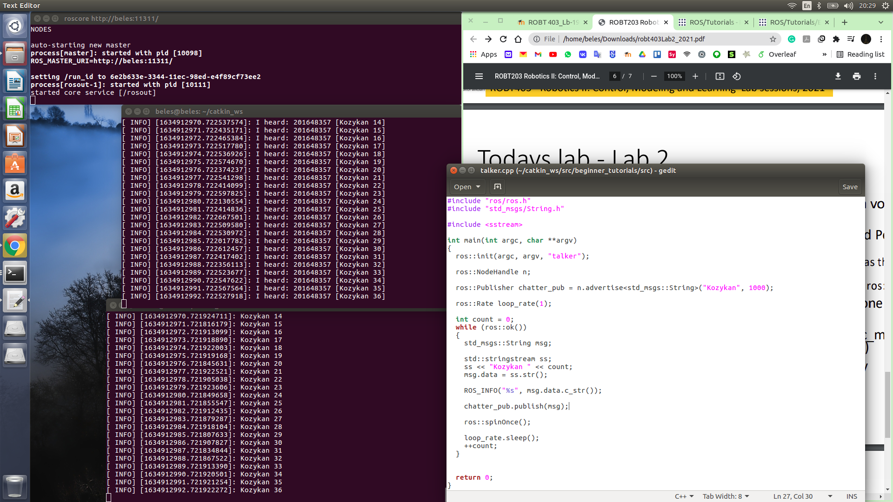The screenshot of step 11 in ROS tutorials: